**OPERATING SYSTEMS**



Session: 2022 – 2026

**Project: Window download**

**Submitted By:**

HABIB UL REHMAN 2022-CS-201

M SOBAN AKRAM 2022-CS-173

**Submitted To:**

DR. NUMAN SHAFI

**Department of Computer Science**

**University of Engineering and Technology**

**Lahore Pakistan**

**Objective:**

In this lab we will learn about the window downloading. After follow the given steps you will be able to download window in your device and there will be no need to go to the Hafeez center and to the Seniors to get help about this.  
So follow these steps.

**Step 1:**

First of all go the Google and search VMware and download it by clicking on the first link.

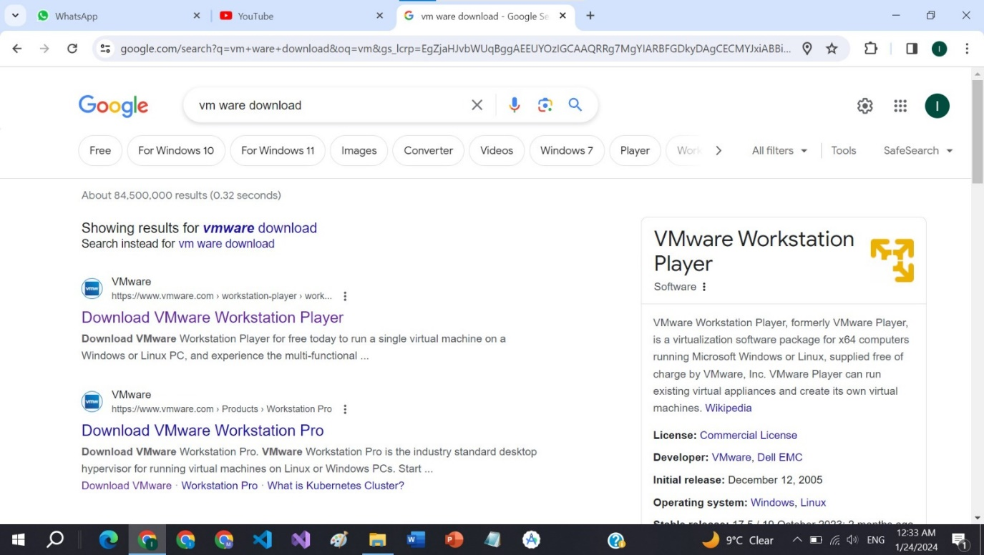

**Step 2:**

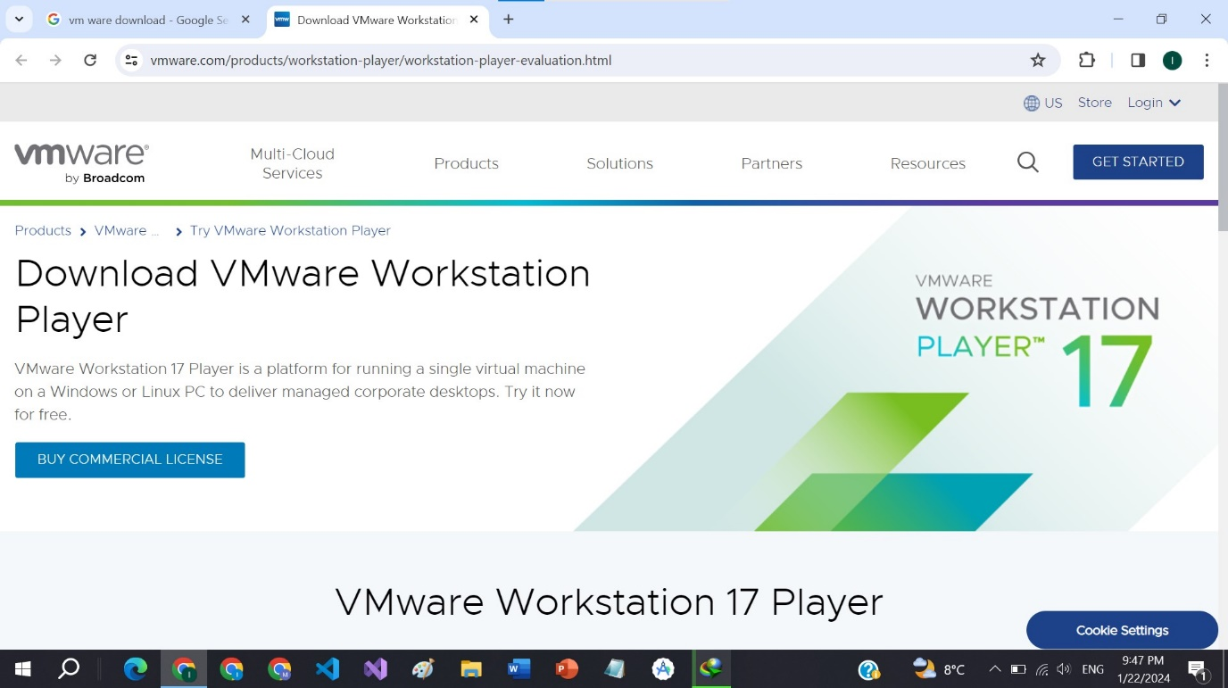 Click on the **GET STARTED** and then continue.

**Step 3:**

Click on the **TRY WORKSTATION 17 PLAYER FOR WINDOWS.**

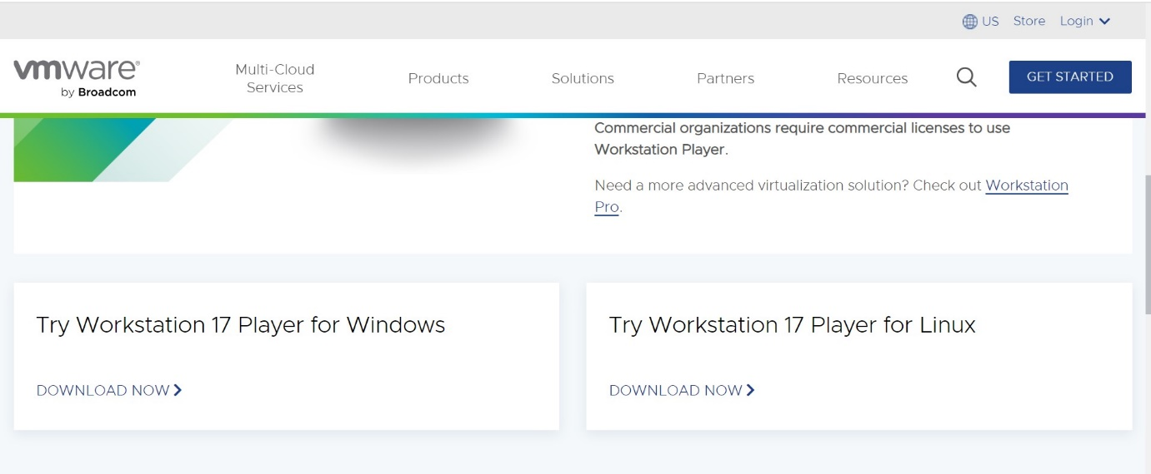

**Step 4:**

Click on the Create new virtual machine. 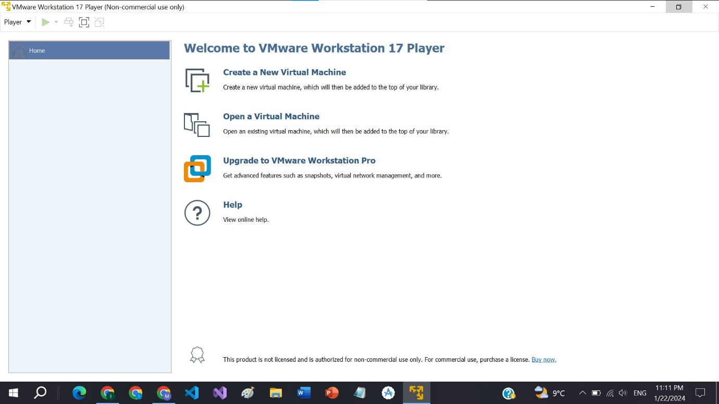

**Step 5:**

Give path of the ISO file by clicking on the browse.

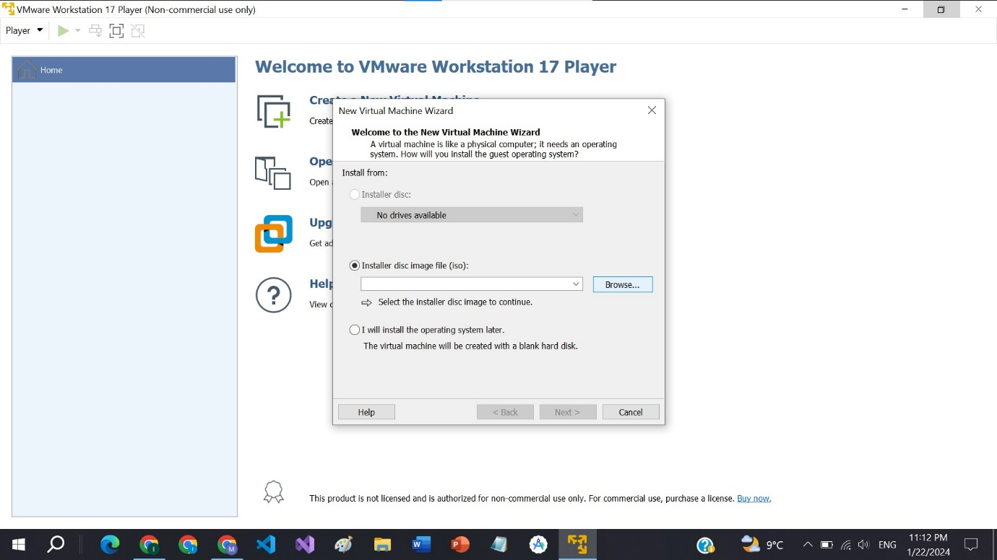

**Step 6:**

Generate your password here and go to the next.

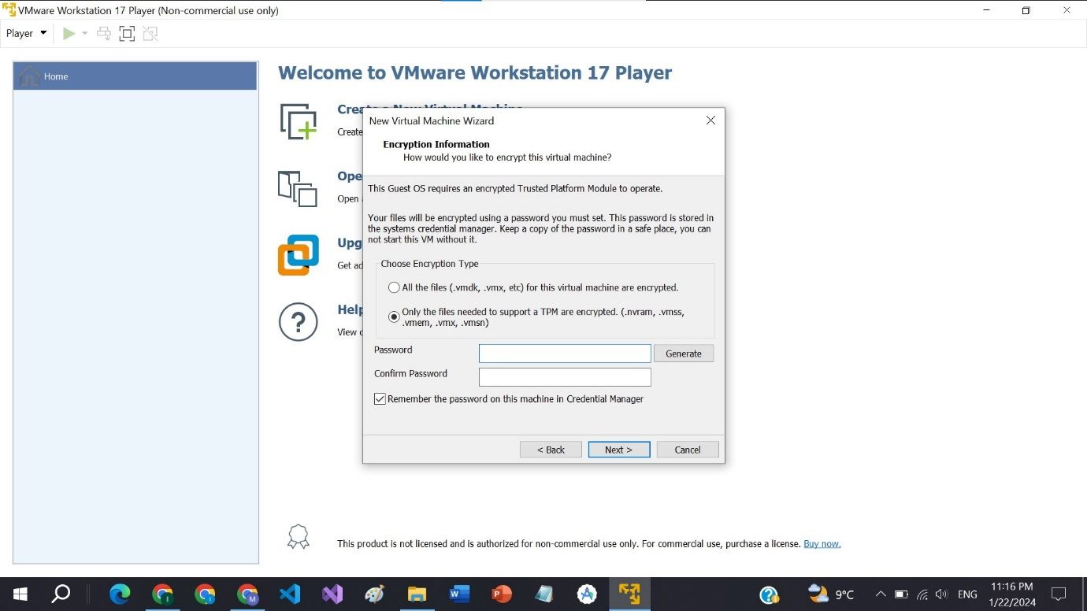

**Step 7:**

Give size maximum 50 or more.

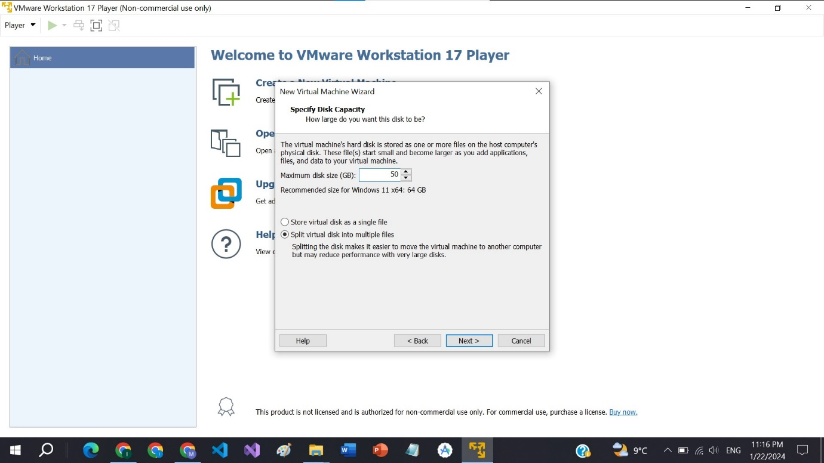

**Step 8:**

Click on customize hardware button to allocate RAM and Memory.

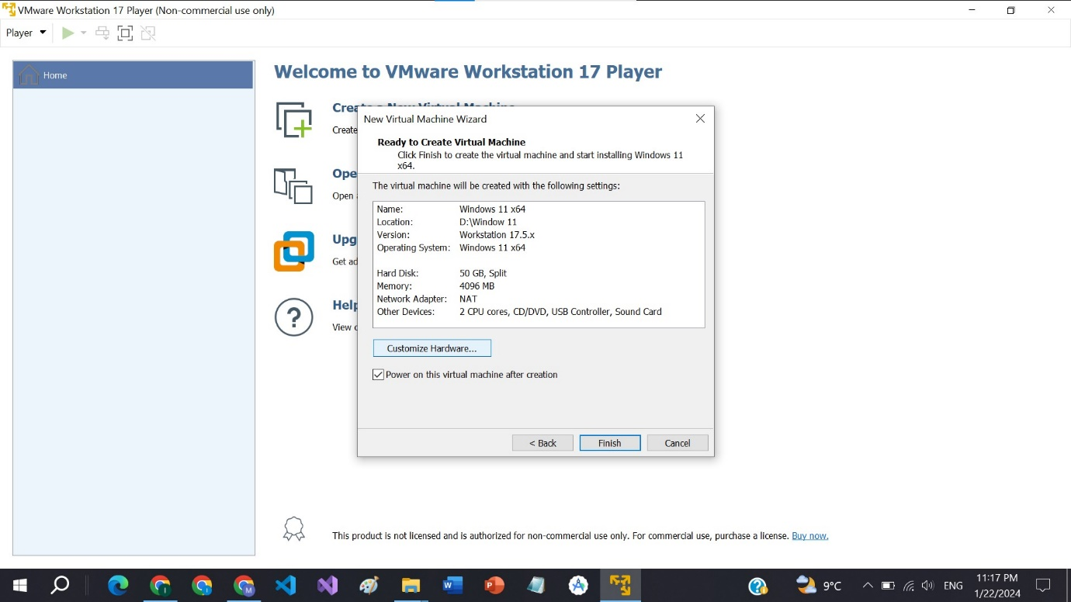

**Step 9:**

Make sure that the allocated memory is 4GB and then click on the close button.

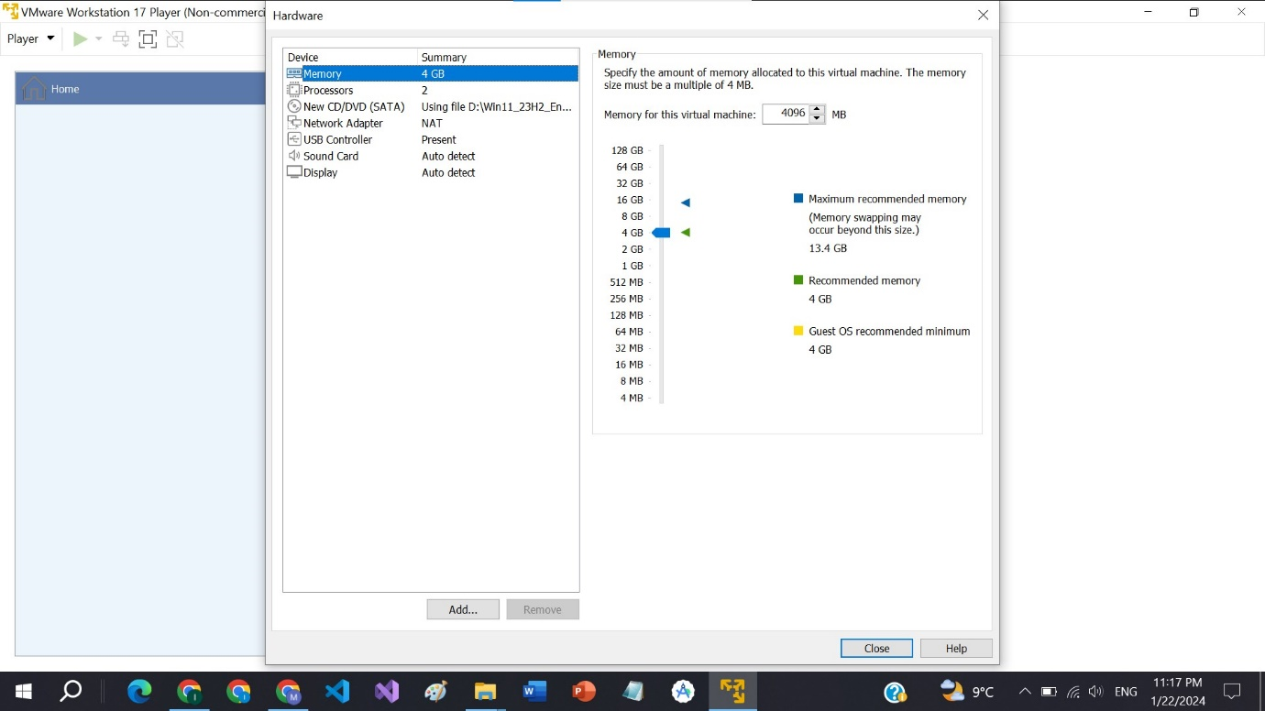

**Step 10:**

Select the language and go to the next.

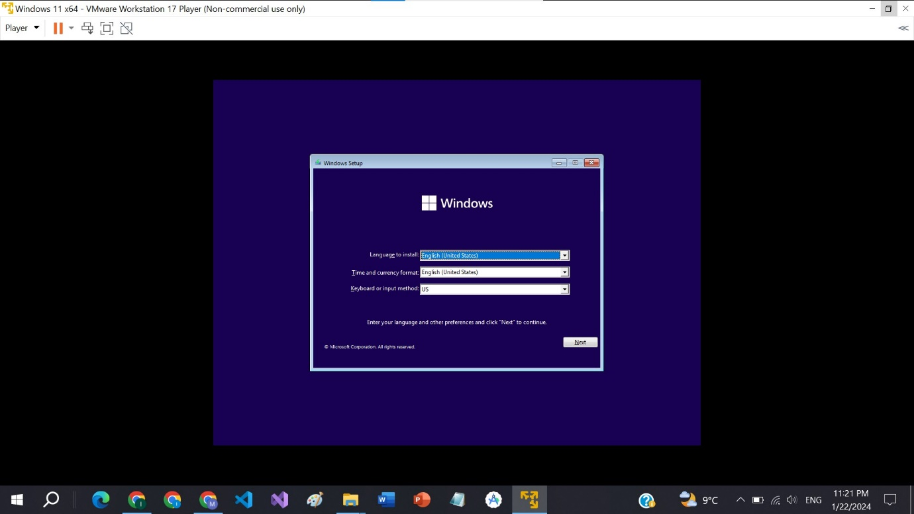

**Step 11:**

Now click on the install button.

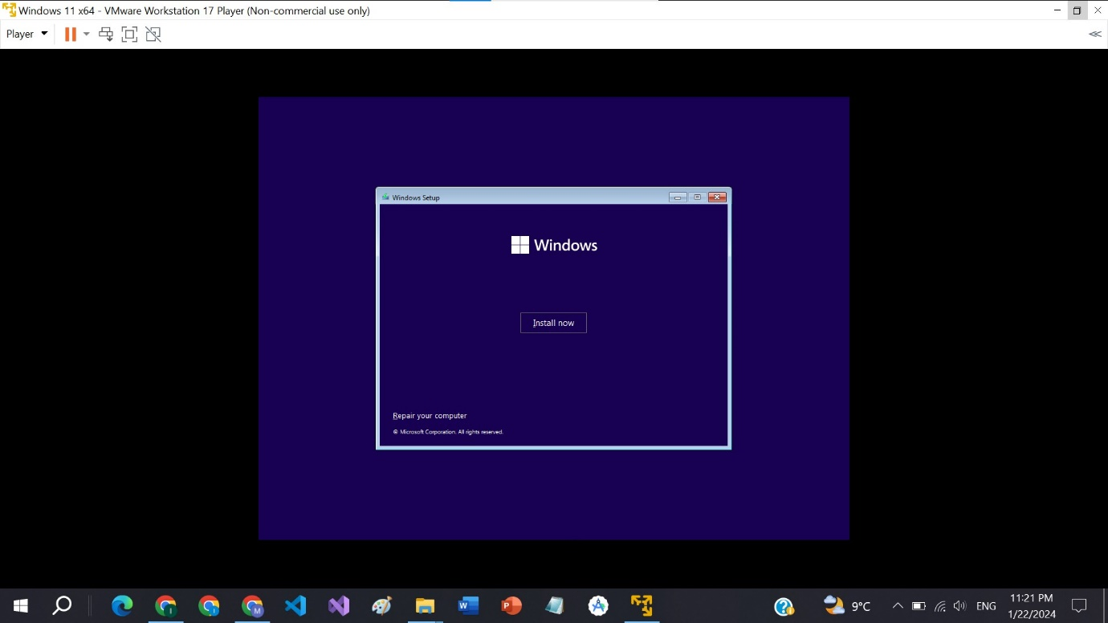

**Step 12:**

Select the window version any you want.

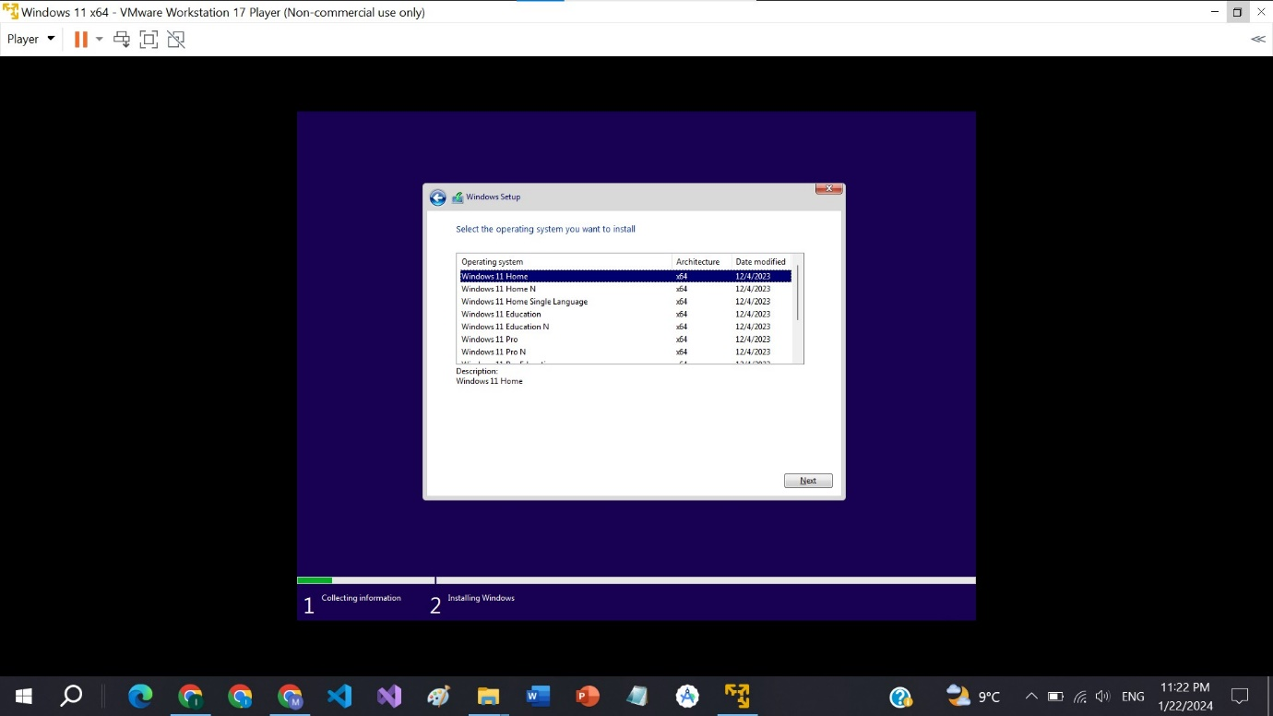

**Step 13:**

Now check the box and go to the next.

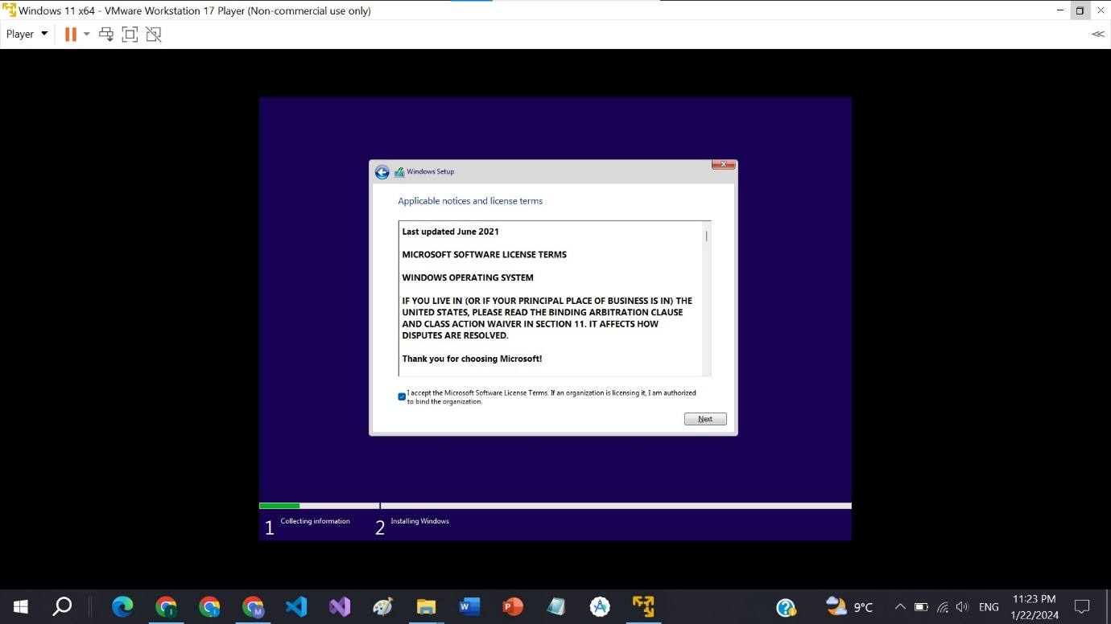

**Step 14:**

Click on the Custom: Install windows only (advanced).

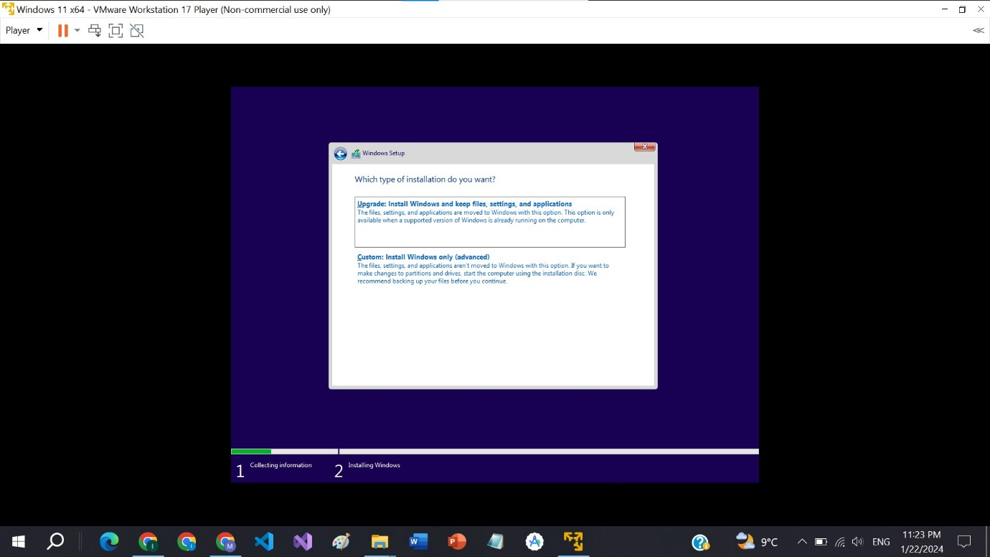

**Step 15:**

Click on the next button and go forward.

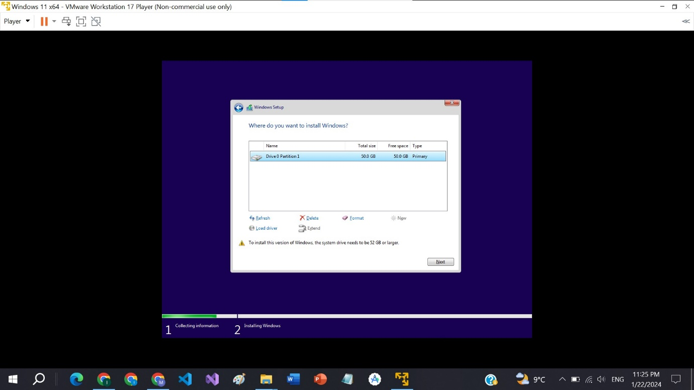

**Step 16:**

Now window is installing.

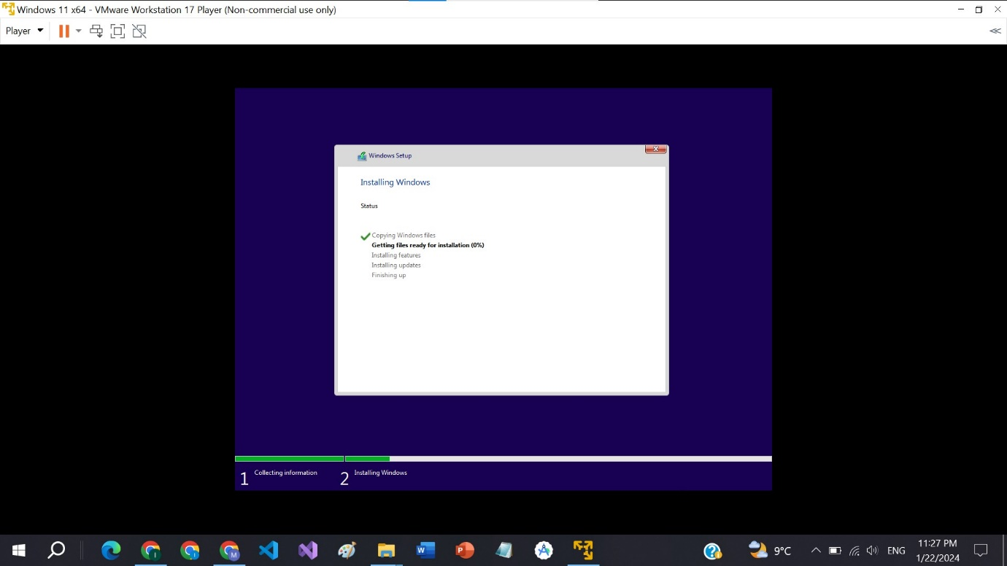

**Step 17:**

Choose country and click on the yes button.

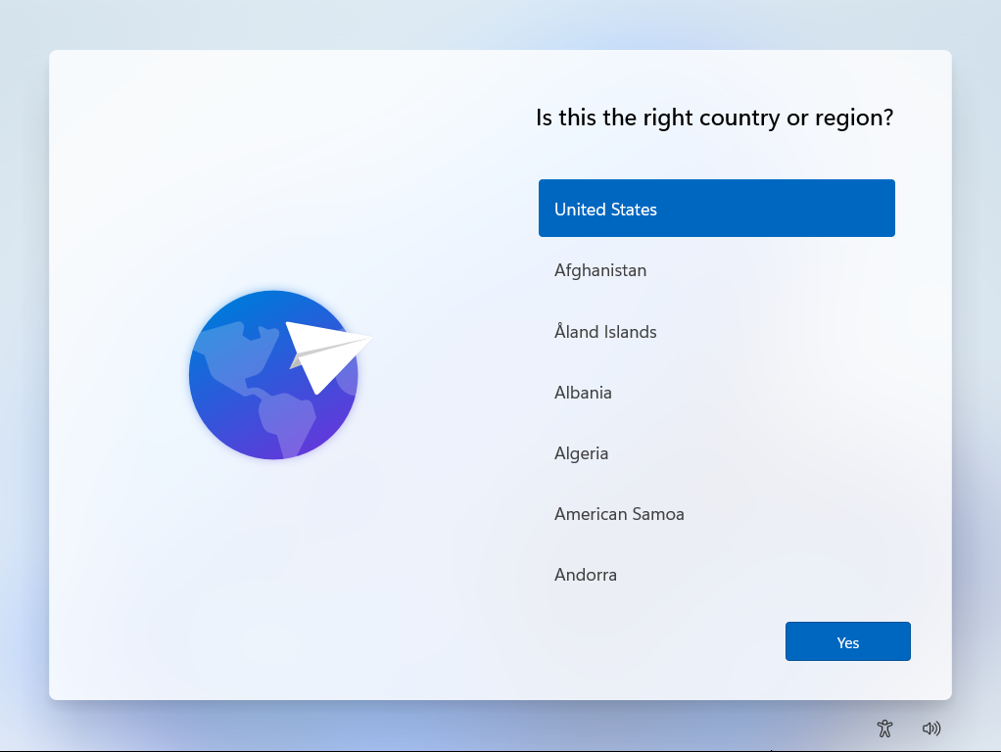

**Step 18:**

Choose keyboard layout or input method and click on the yes button.

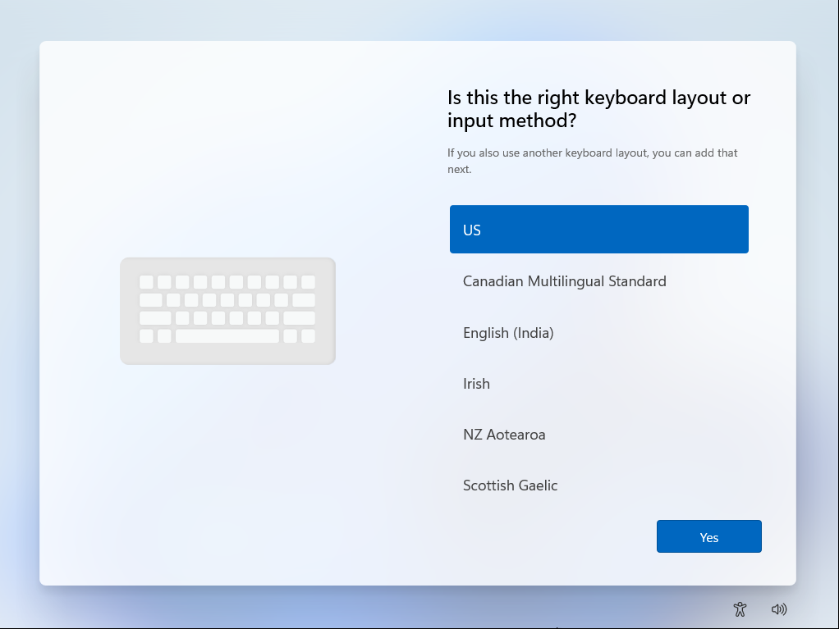

**Step 19:**

Click on the skip button.

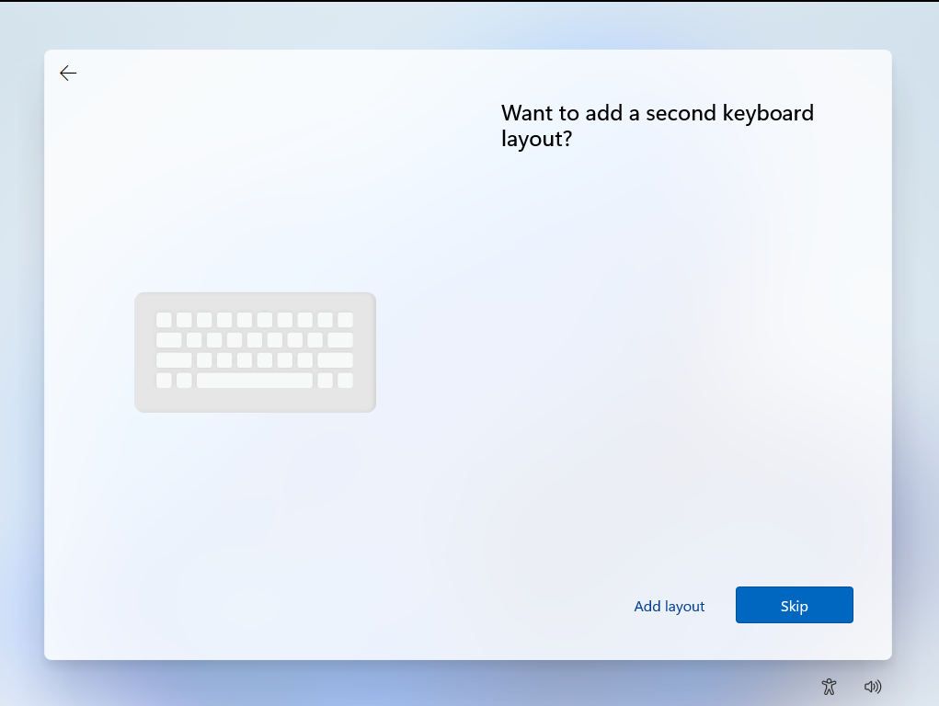

**Step 20:**

Give name to your device and click on the next button.

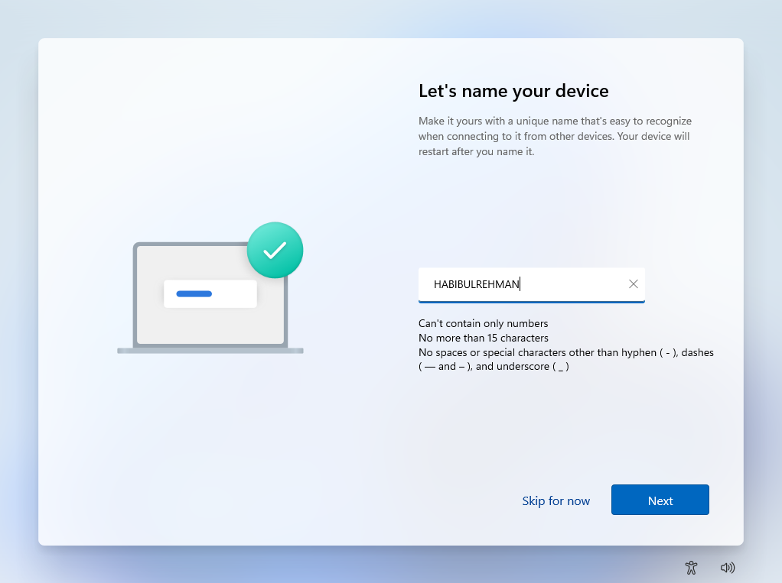

**Step 21:**

Click on the setup for personal use.

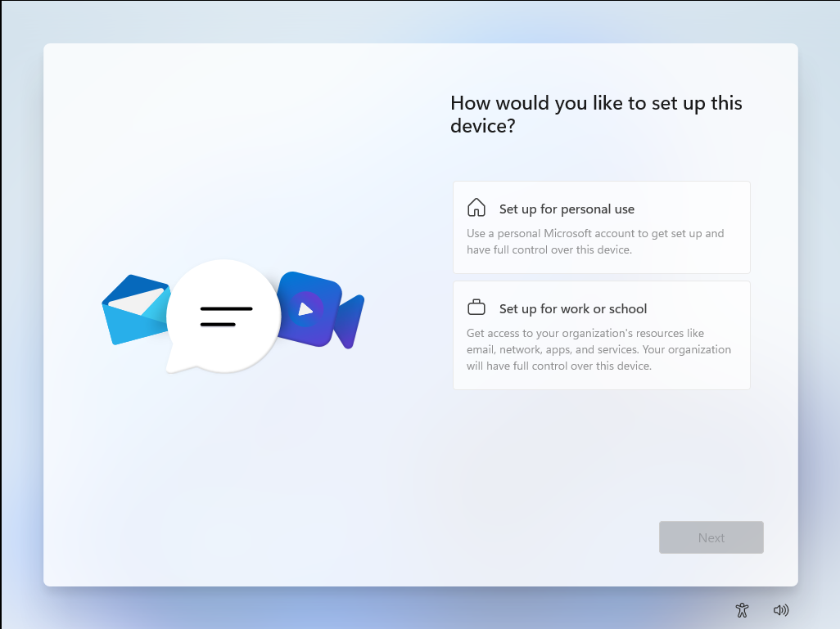

**Step 22:**

After clicking on the set up for personal use click on the next button.

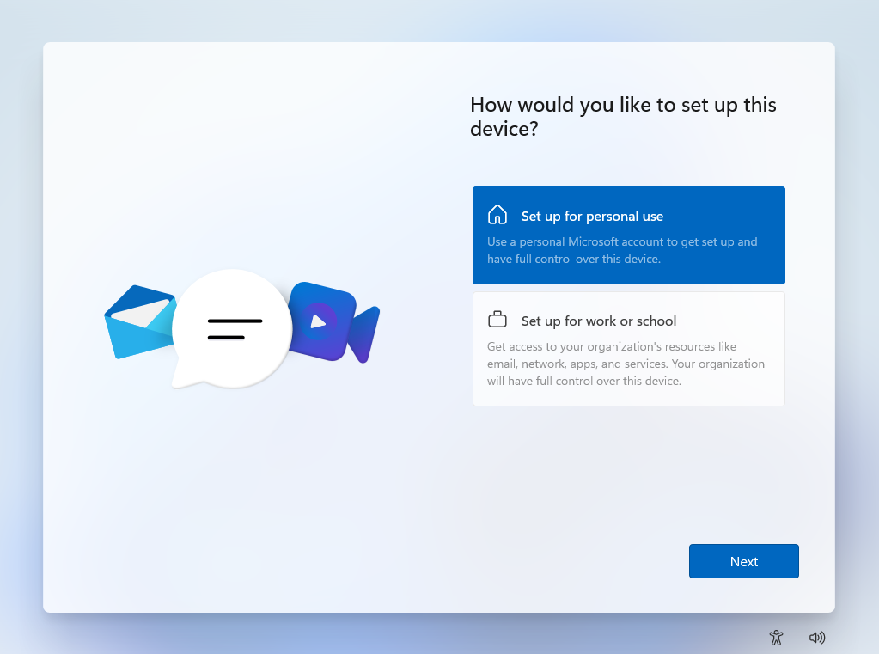

**Step 23:**

Click on the sign in and create account.

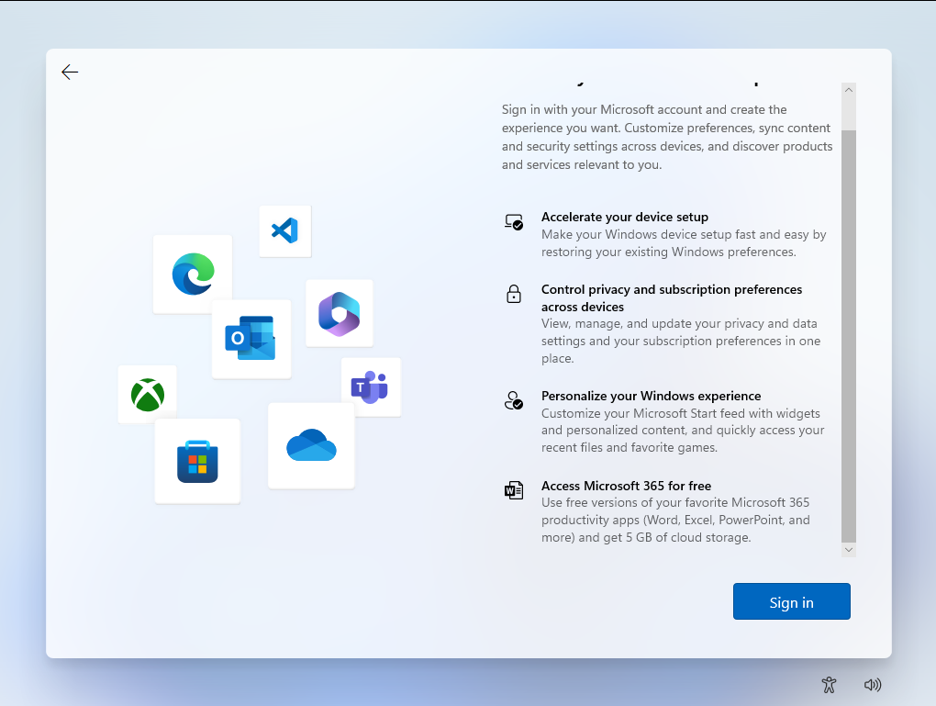

**Step 24:**

Write your email and click on the next button.

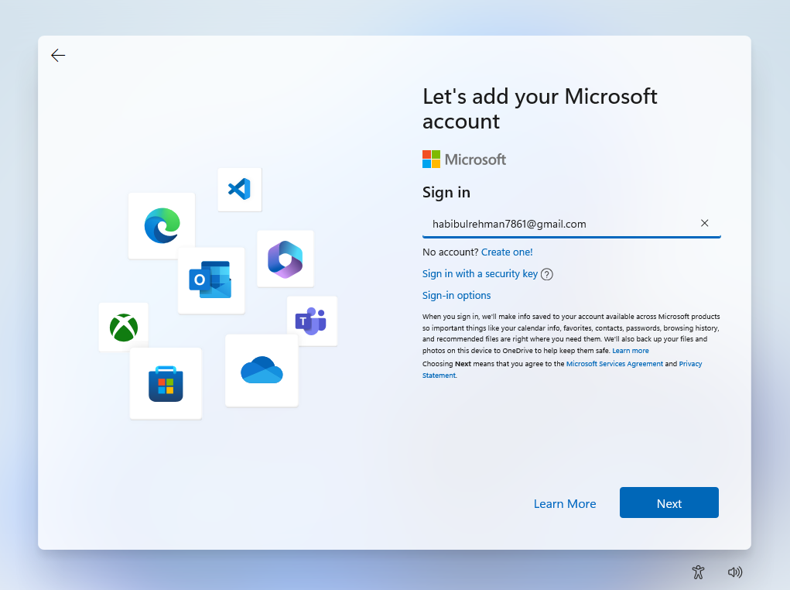

**Step 25:**

Enter your password and click on the sign in button.

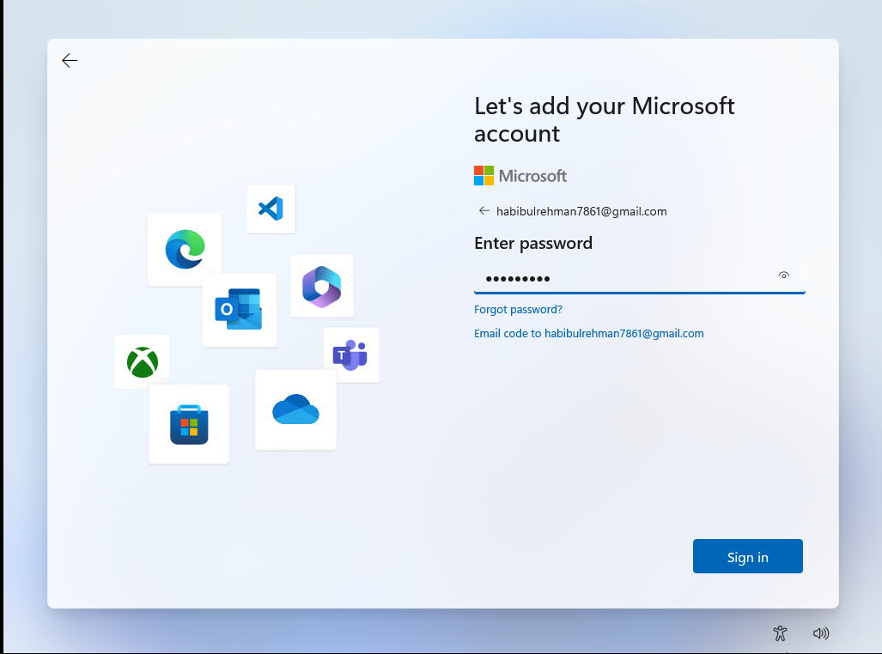

**Step 26:**

Click on the more option button.

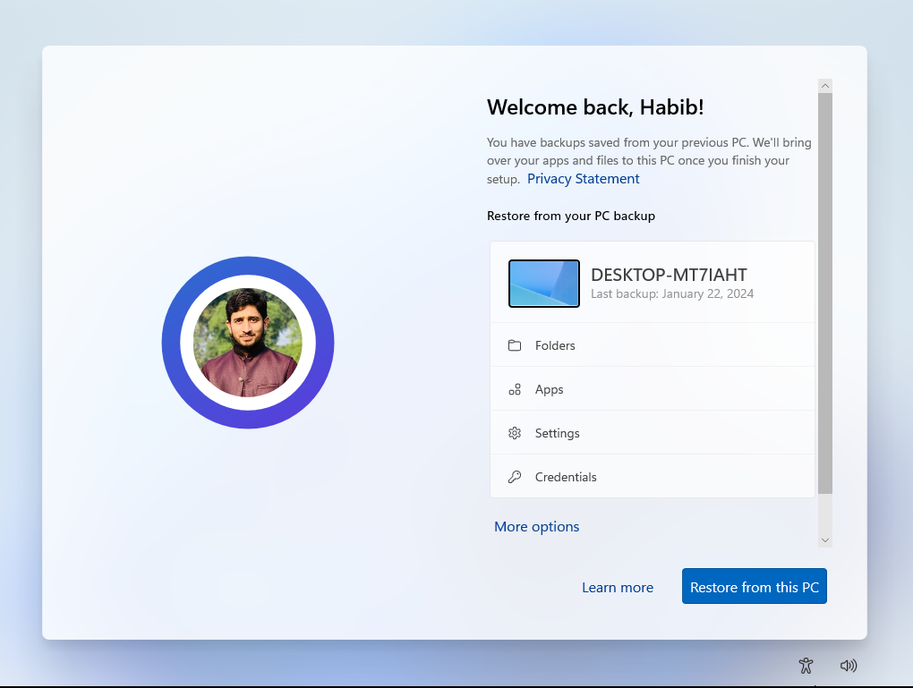

**Step 27:**

Click on the to setup a new PC.

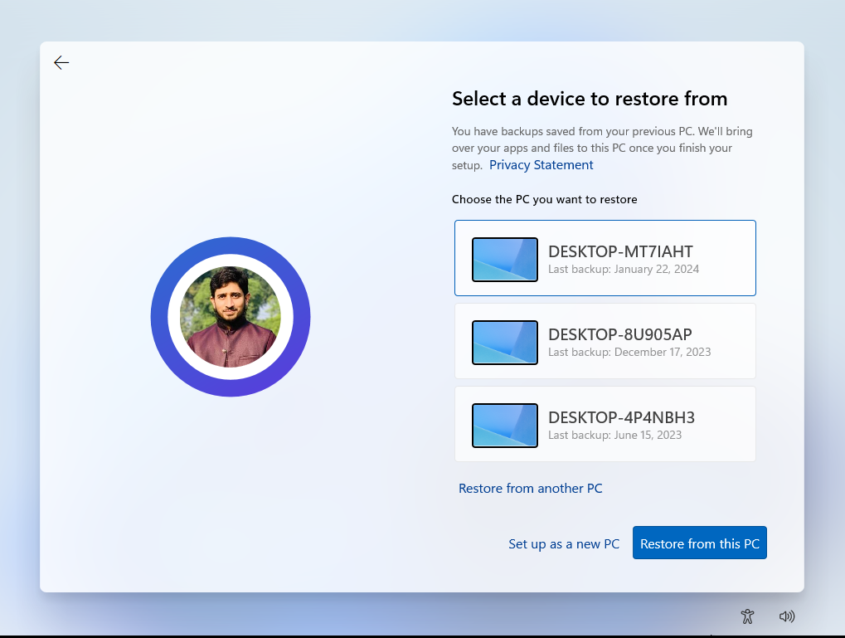

**Step 28:**

Now create pin if you want by clicking on the button.

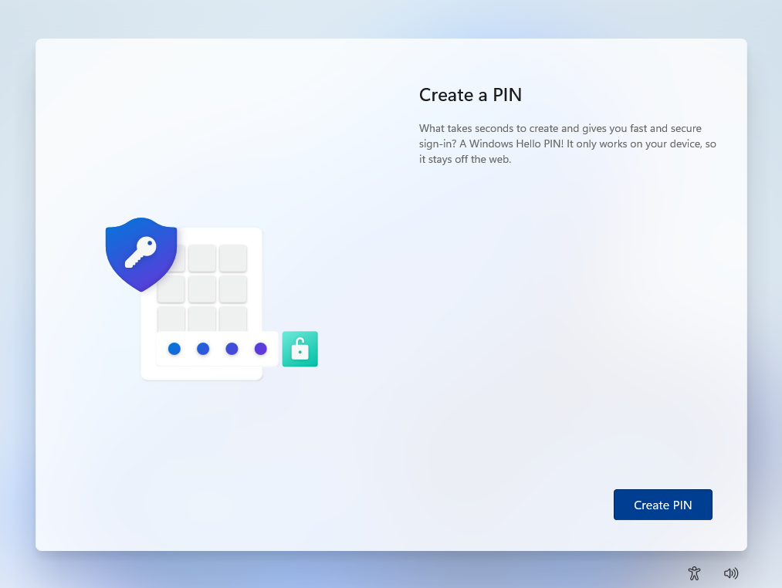

**Step 29:**

Set up PIN and click on the OK button.

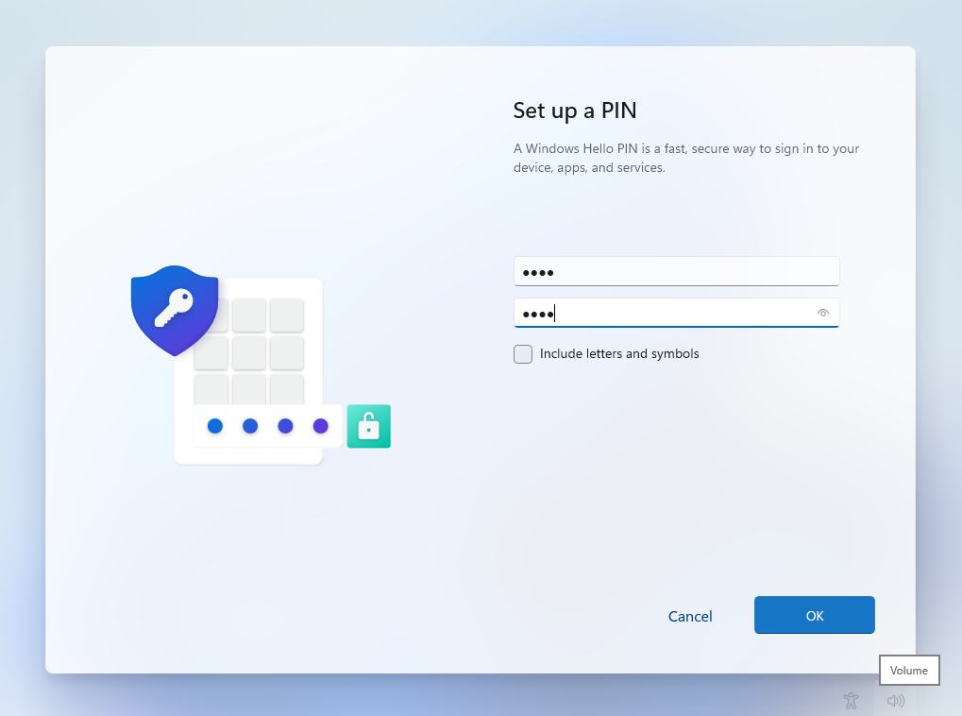

**Step 30:**

Now click on the next button. 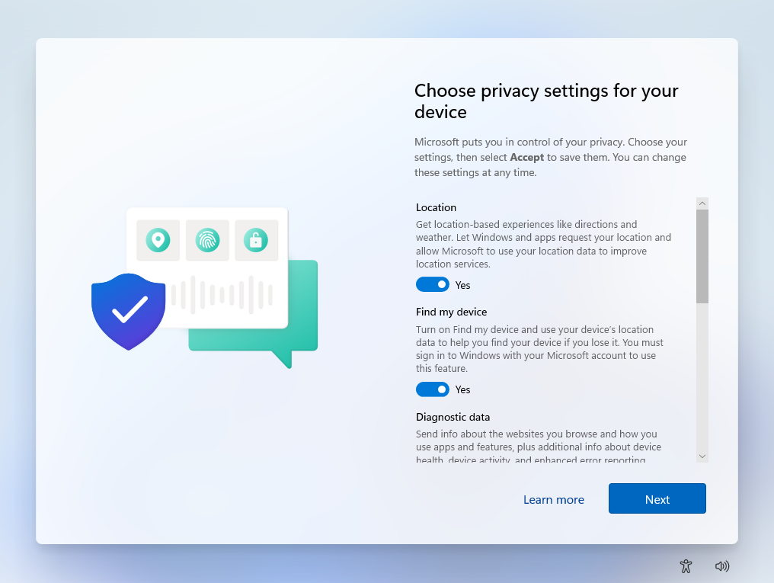

**Step 31:**

Check all the boxes and click on the accept button.

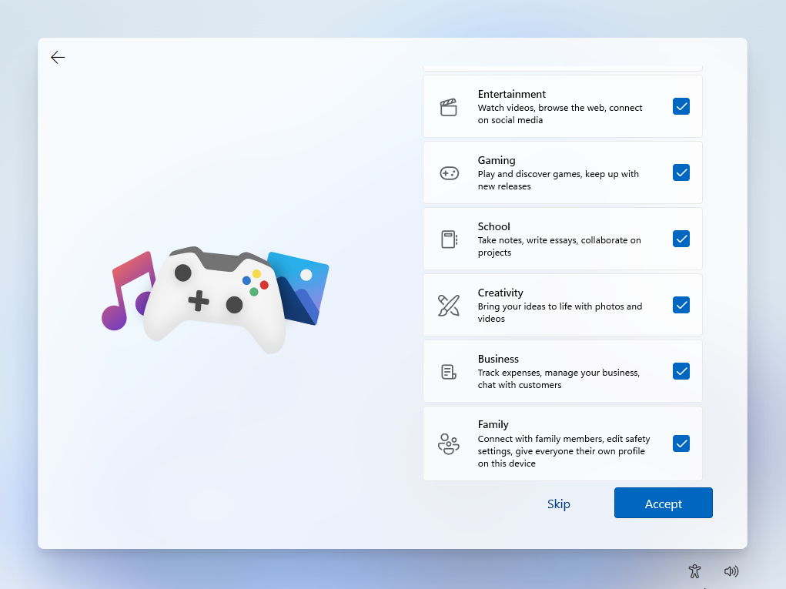

**Step 32:**

Click on the skip button.

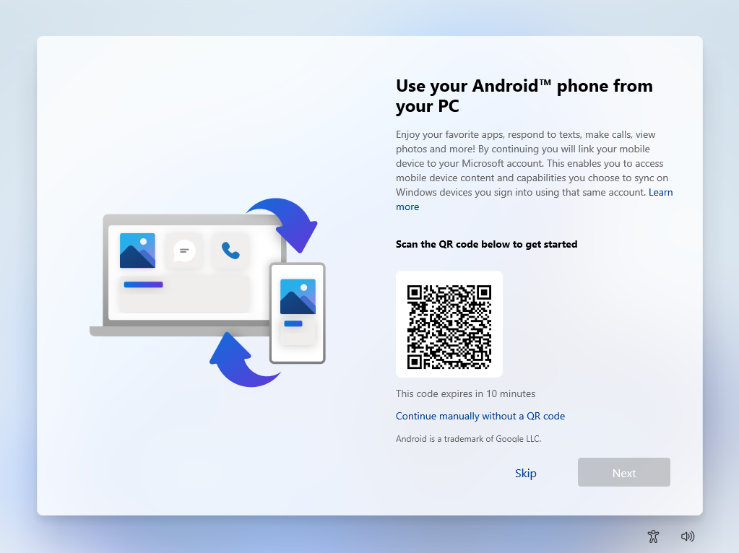

**Step 33:**

Click on the accept button.

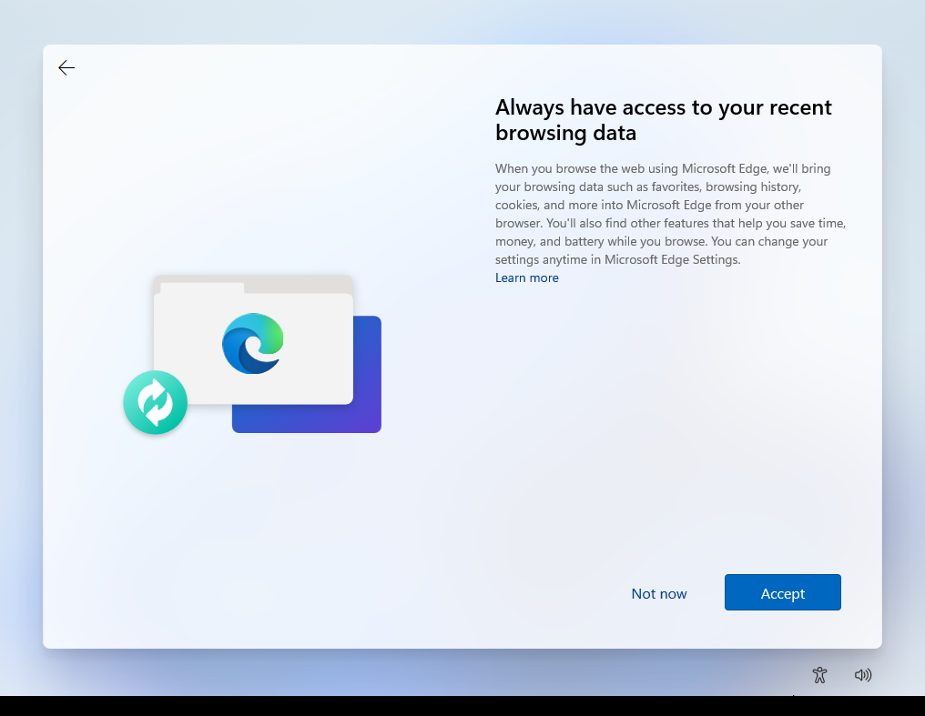

**Step 35:**

Click on the decline button.

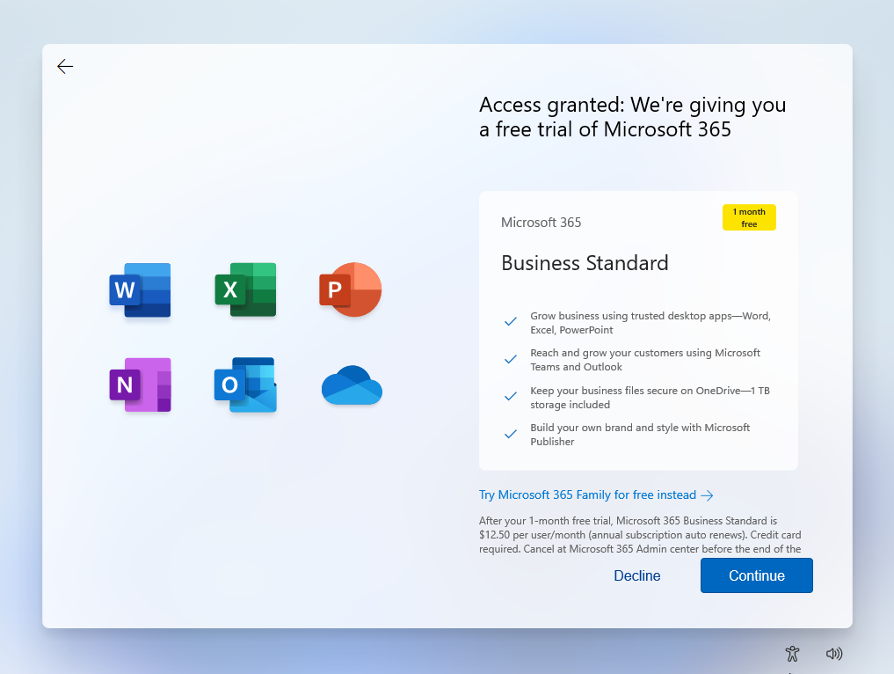

**Step 36:**

Wait and keep loading.



**Step 37:**

Enter pin that you have set already.

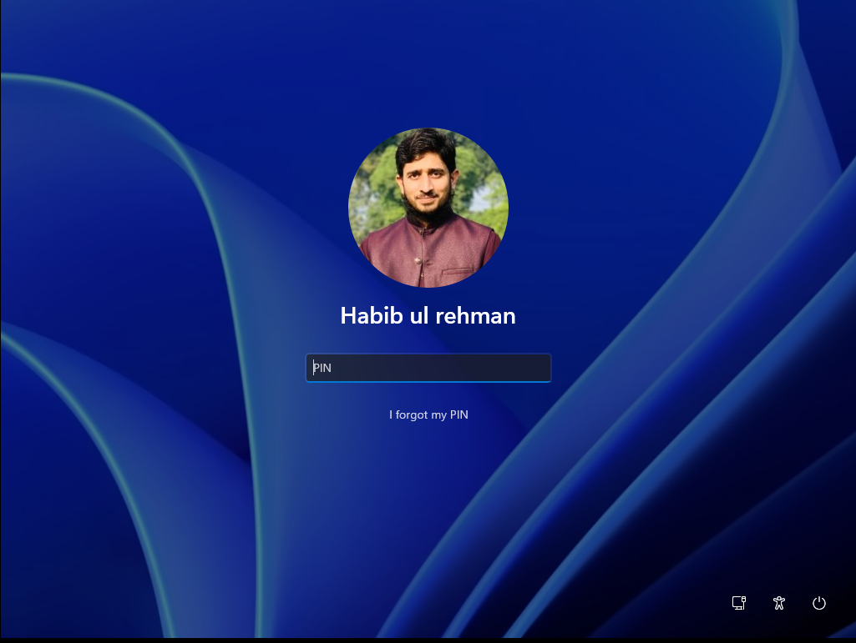

**Step 38:**

Now window is completely installed you can do your work properly.

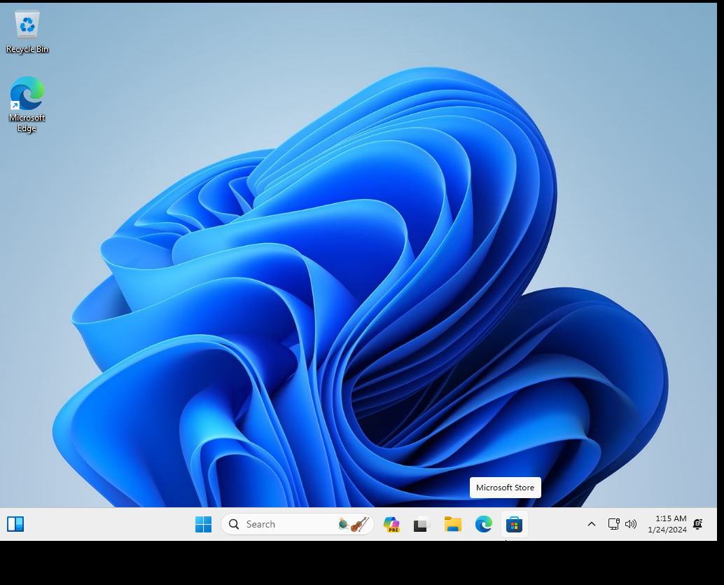

**GOOD LUCK**